FORM 10-Q
U.S. SECURITIES AND EXCHANGE COMMISSION
Washington, D.C. 20549
(Mark One)
[X] | QUARTERLY REPORT PURSUANT TO SECTION 13 OR 15(d) OF THE SECURITIES EXCHANGE ACT OF 1934  For the quarterly period ended: August 31, 2011
[ ] | TRANSITION REPORT UNDER SECTION 13 OR 15(d) OF THE SECURITIES EXCHANGE ACT OF 1934  For the transition period from ________________ to _________________  Commission file number: 0-31555
BAB, Inc.
(Name of small business issuer in its charter)

Delaware | 36-4389547
(State or other jurisdiction of incorporation or organization) | (I.R.S. Employer Identification No.)
500 Lake Cook Road, Suite 475, Deerfield, Illinois 60015
(Address of principal executive offices) (Zip Code)
Issuer's telephone number (847) 948-7520
Indicate by checkmark whether the registrant (1) filed all reports required to be filed by Section 13 or 15(d) of the Exchange Act during the preceding 12 months (or for such shorter period that the registrant was required to file such reports), and (2) has been subject to such filing requirements for the past 90 days. Yes x No
Indicate by check mark whether the registrant has submitted electronically and posted on its corporate Web site, if any, every Interactive Data File required to be submitted and posted pursuant to Rule 405 of Regulation S-T (§232.405 of this chapter) during the preceding 12 months (or for such shorter period that the registrant was required to submit and post such files). Yes No
Indicate by checkmark whether the registrant is a large accelerated filer, accelerated filer, a non-accelerated filer, or a smaller reporting company.
Large accelerated filer Accelerated filer Non-accelerated filer (Do not
check if a smaller reporting company) Smaller reporting company x
Indicate by checkmark whether the registrant is a shell company. Yes No x
As of October 2, 2011, BAB, Inc. had: 7,263,508 shares of Common Stock outstanding.

TABLE OF CONTENTS
PART I | FINANCIAL INFORMATION
Item 1. | Financial Statements
Item 2 | Management's Discussion and Analysis of Financial Condition and Results of Operation
Item 3 | Quantitative and Qualitative Disclosures About Market Risk
Item 4 | Controls and Procedures
PART II | OTHER INFORMATION
Item 1. | Legal Proceedings
Item 2 | Unregistered Sales of Equity Securities and Use of Proceeds
Item 3 | Defaults Upon Senior Securities
Item 4 | Other Information
Item 5 | Exhibits
SIGNATURE

PART I
ITEM 1. | FINANCIAL STATEMENTS

BAB, Inc.
Consolidated Balance Sheet
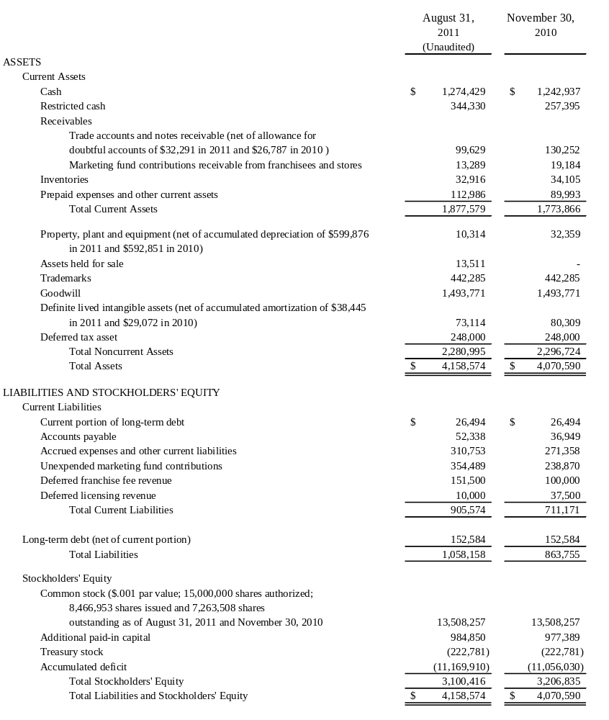
SEE ACCOMPANYING NOTES

BAB, Inc.
Consolidated Statements of Operations
For the Quarters Ended August 31, 2011 and 2010
(Unaudited)

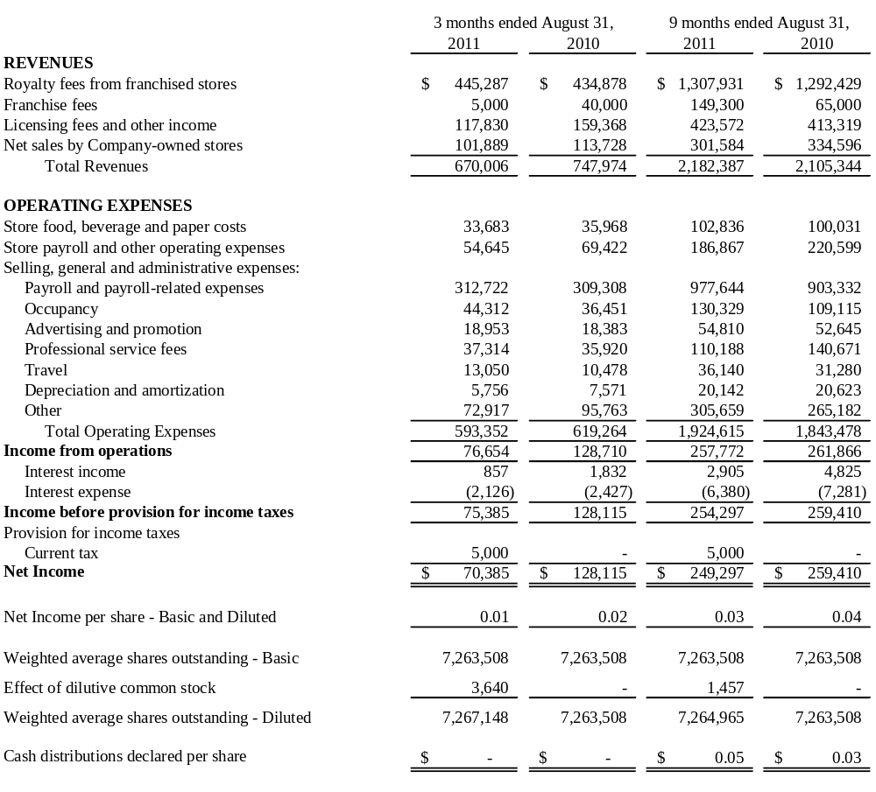
SEE ACCOMPANYING NOTES

BAB, Inc.
Consolidated Statements of Cash Flows
For the Nine Months Ended August 31, 2011 and 2010
(Unaudited)

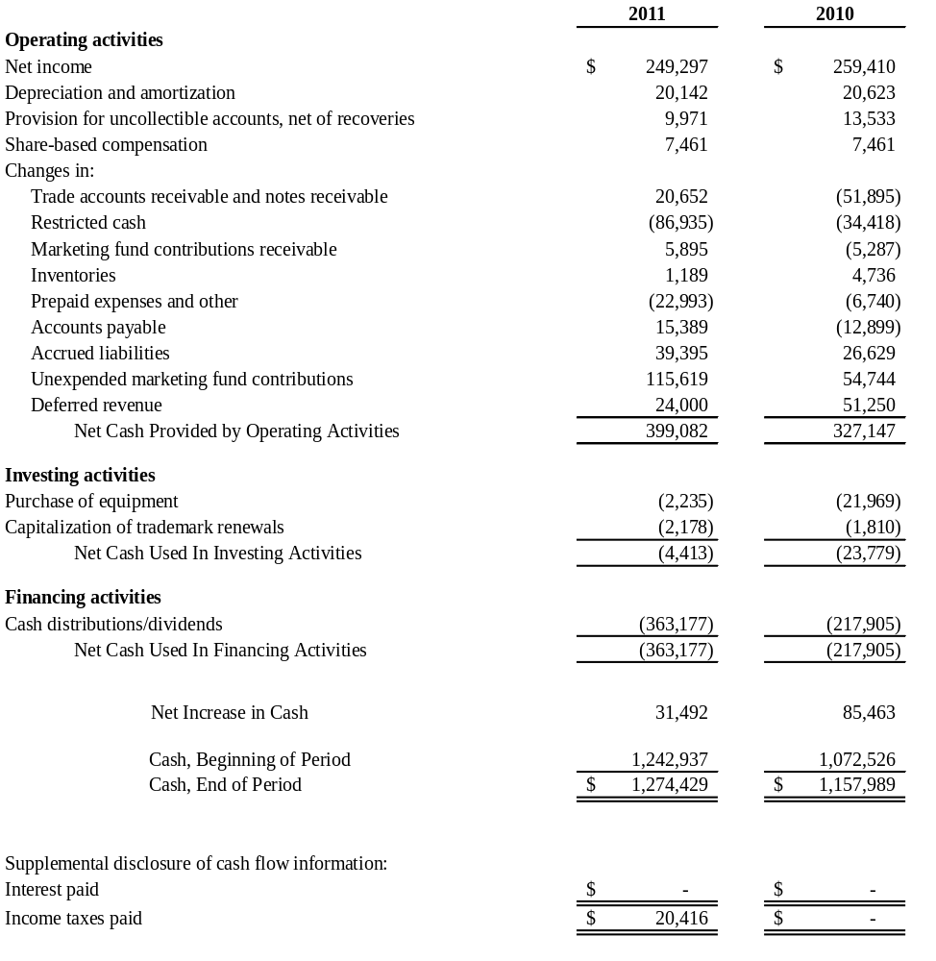

SEE ACCOMPANYING NOTES

BAB, Inc.
Notes to Unaudited Consolidated Financial Statements
Quarter and Year to Date Periods Ended August 31, 2011 and 2010
(Unaudited)

Note 1 - Nature of Operations
BAB, Inc has four wholly owned subsidiaries: BAB Systems, Inc. (“Systems”); BAB Operations, Inc. (“Operations”); Brewster’s Franchise Corporation (“BFC”) and My Favorite Muffin Too, Inc. Systems was incorporated on December 2, 1992, and was primarily established to franchise Big Apple Bagel (“BAB”) specialty bagel retail stores. Operations was formed on August 30, 1995, primarily to operate Company-owned stores, including one which currently serves as the franchise training facility. BFC was established on February 15, 1996 to franchise “Brewster’s Coffee” concept coffee stores. My Favorite Muffin Too, Inc., a New Jersey corporation, was acquired on May 13, 1997. My Favorite Muffin Too, Inc. franchises My Favorite Muffin (“MFM”) concept muffin stores which are included as part of the Systems franchise operating and financial information. The assets of Jacobs Bros. Bagels (“Jacobs Bros.”) were acquired on February 1, 1999. All branded wholesale business uses this trademark.

The Company was incorporated under the laws of the State of Delaware on July 12, 2000. The Company currently operates franchises and licenses bagel and muffin retail units under the BAB and MFM trade names. At August 31, 2011, the Company had 97 franchise units, 8 licensed units and one Company-owned store in operation in 26 states. The Company additionally derives income from the sale of its trademark bagels, muffins and coffee through nontraditional channels of distribution including under licensing agreements with Mrs. Fields Famous Brands (Mrs. Fields), Kohr Bros. Frozen Custard, Braeda Cafe, Kaleidoscoops, Green Beans Coffee, Sodexo and through direct home delivery of specialty muffin gift baskets and coffee.
The accompanying condensed consolidated financial statements are unaudited. These financial statements have been prepared in accordance with the rules and regulations of the Securities and Exchange Commission. Certain information and footnote disclosures normally included in financial statements prepared in accordance with U.S. generally accepted accounting principles have been omitted pursuant to such SEC rules and regulations; nevertheless, the Company believes that the disclosures are adequate to make the information presented not misleading. These financial statements and the notes hereto should be read in conjunction with the financial statements and notes thereto included in the Company's Annual Report on Form 10-K for the year ended November 30, 2010 which was filed February 24, 2011. In the opinion of the Company's management, the condensed consolidated financial statements for the unaudited interim periods presented include all adjustments, including normal recurring adjustments, necessary to fairly present the results of such interim periods and the financial position as of the end of said period. The results of operations for the interim period are not necessarily indicative of the results for the full year.
2. Locations Open and Under Development
Locations which are open or under development at August 31, 2011 are as follows:
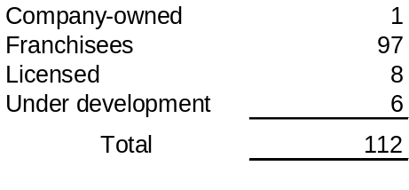

3. (Loss)/Earnings per Share
The following table sets forth the computation of basic and diluted earnings per share:
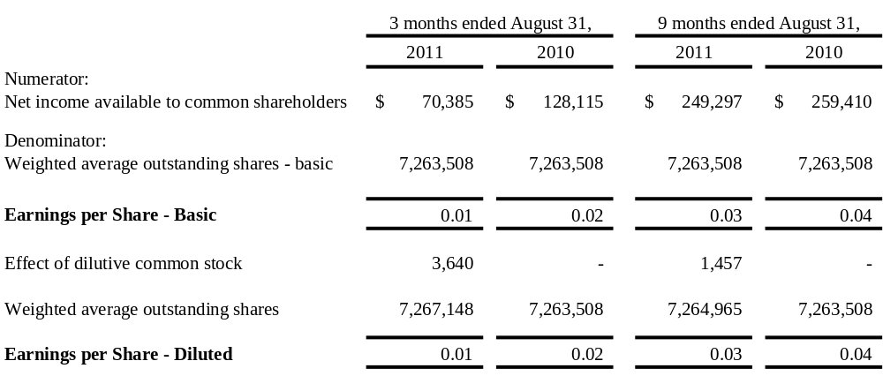350,400 and 368,373 potential shares attributable to outstanding stock options were excluded from the calculation of diluted earnings per share for the three and nine months ended August 31, 2011and 2010, respectively, because their inclusion would have been anti-dilutive.
4. Long-Term Debt
The total debt balance of $179,078 represents a note payable to a former shareholder that requires an annual payment of $35,000, including interest at 4.75%, due October 1 and running through 2016.
5. Stock Options
In May 2001, the Company approved a Long-Term Incentive and Stock Option Plan (Plan). The Plan reserves 1,400,000 shares of common stock for grant. As of August 31, 2011, 1,400,000 stock options were granted to directors, officers and employees. As of August 31, 2011, there were 1,031,627 stock options exercised or forfeited under the Plan.
 | 9 Months Ended
 | August 31, 2011 |  | August 31, 2010
 | Options |  | Options
Options Outstanding at beginning of period | 368,373 |  | 368,373
Granted | 0 |  | 0
Forfeited | 0 |  | 0
Exercised | 0 |  | 0
Options Outstanding at end of period | 368,373 |  | 368,373
The Company recorded compensation cost arising from share-based payment arrangements in payroll-related expenses on the Condensed Consolidated Statement of Operations for the Company’s stock option plan of approximately $7,000 for the nine months ended August 31, 2011 and 2010.

As of August 31, 2011, there was approximately $2,000 of total unrecognized compensation cost related to non-vested stock option compensation arrangements granted under the incentive plan. That cost is to be recognized over the balance of this fiscal year.
The Company uses historical volatility of common stock over a period equal to the expected life of the options to estimate their fair value. The dividend yield assumption is based on the Company’s history and expectation of future dividend payouts on the common stock. The risk-free interest rate is based on the implied yield available on U.S. treasury zero-coupon issues with an equivalent remaining term. The expected term of the options represents the estimated period of time until exercise and is based on historical experience of similar awards, giving consideration to the contractual terms, vesting schedules and expectations of future employee behavior. To value option grants and other awards for actual and pro forma stock-based compensation, the Company uses the Black-Scholes option valuation model. When the measurement date is certain, the fair value of each option grant is estimated on the date of grant and is based on the assumptions used for the expected stock price volatility, expected term, risk-free interest rates and future dividend payments.

The Company’s stock option terms expire in 10 years and vary in vesting from immediate to a vesting period of five years.

The following table summarizes the stock options outstanding and exercisable at August 31, 2011:

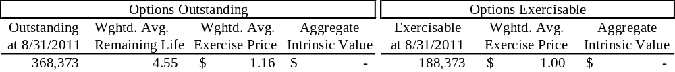
There is no computation for the aggregate intrinsic value in the table above because the outstanding options weighted average exercise price was greater than the Company’s closing stock price of $.69 as of the last business day of the period ended August 31, 2011. No options were exercised during the quarter ended August 31, 2011.

6. Goodwill and Other Intangible Assets
In accordance with ASC 350, goodwill and indefinite-lived intangible assets are tested for impairment upon adoption of the standard and annually thereafter. ASC 350 requires that goodwill be tested for impairment using a two-step process. The first step is to identify a potential impairment and the second step measures the amount of the impairment loss, if any. Goodwill is deemed to be impaired if the carrying amount of a reporting unit's net assets exceeds its estimated fair value. ASC 350 requires that indefinite-lived intangible assets be tested for impairment using a one-step process, which consists of a comparison of the fair value to the carrying value of the intangible asset. Intangible assets are deemed to be impaired if the net book value exceeds the estimated fair value.
Following the guidelines contained in ASC 350, the Company tests goodwill and intangible assets that are not subject to amortization for impairment annually or more frequently if events or circumstances indicate that impairment is possible. Goodwill and intangible assets were tested at the end of fiscal quarter, February 28, 2011 and it was found that the carrying value of the goodwill and intangible assets was not impaired. No events or circumstances occurred in the third quarter of 2011 to indicate that an impairment test was necessary.

The impairment test performed at February 28, 2011 was based on a discounted cash flow model using management’s business plans projected for expected future cash flows. Based on the computation of the discounted cash flows, it was determined that the fair value of goodwill and intangible assets was in excess of the carrying value.

7. Segment Information
The following table presents segment information for the nine months ended August 31, 2011 and 2010:
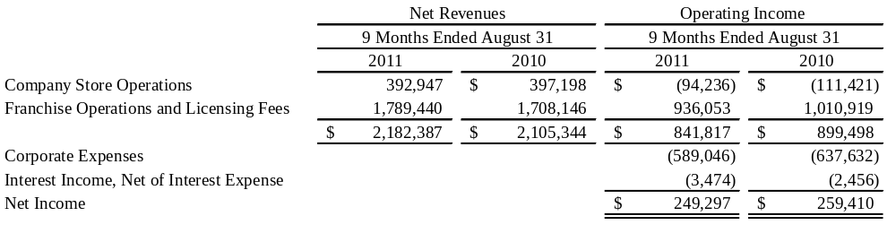Total segment assets were substantially unchanged for the nine months ended August 31, 2011 as compared to November 30, 2010.
8. Recent Accounting Pronouncements
In January 2010, the Financial Accounting Standards Board (FASB) issued Accounting Standard Update (ASU) 2010-06, “Fair Value Measurements and Disclosure.” This guidance requires new disclosures for fair value measurements and provides clarification for existing disclosure requirements. The guidance is effective for interim and annual periods beginning after December 15, 2009, except for gross presentation of activity in level 3 which is effective for annual periods beginning after December 15, 2010, and for interim periods in those years. The adoption of this guidance did not have any impact on the Company’s consolidated financial position, cash flows or results of operations.

In September 2011, the FASB issued ASU No. 2011-08, “Testing Goodwill for Impairment” (the revised standard), to allow entities to use a qualitative approach to test goodwill for impairment. ASU 2011-08 permits an entity to first perform a qualitative assessment to determine whether it is more likely than not that the fair value of a reporting unit is less than its carrying value. If it is concluded that this is the case, it is necessary to perform the currently prescribed two-step goodwill impairment test. Otherwise the two-step goodwill test is not required. ASU 2011-08 will be effective for year ended November 30, 2012. Management is reviewing the specific provisions but does believe it will have an impact on the Company’s consolidated financial position, cash flows or results of operations.

Management does not believe that there are any other recently issued and effective or not yet effective pronouncements as of the filing date that would have or are expected to have any significant effect on the Company’s consolidated financial position, cash flows or results of operations.

9. Subsequent Events

On September 6, 2011 a cash distribution of $0.01 was declared, payable on October 4, 2011 to shareholders of record as of September 19, 2011. The cash distribution will be $72,635.

ITEM 2. | MANAGEMENT'S DISCUSSION AND ANALYSIS OF FINANCIAL CONDITION AND RESULTS OF OPERATIONS
Certain statements contained in Management's Discussion and Analysis of Financial Condition and Results of Operations, including statements regarding the development of the Company's business, the markets for the Company's products, anticipated capital expenditures, and the effects of completed and proposed acquisitions, and other statements contained herein regarding matters that are not historical facts, are forward-looking statements as is within the meaning of Section 27A of the Securities Act of 1933 and Section 21E of the Securities Exchange Act of 1934. Because such statements include risks and uncertainties, actual results could differ materially from those expressed or implied by such forward-looking statements as set forth in this report, the Company's Annual Report on Form 10-K and other reports that the Company files with the Securities and Exchange Commission. Certain risks and uncertainties are wholly or partially outside the control of the Company and its management, including its ability to attract new franchisees; the continued success of current franchisees; the effects of competition on franchisees and Company-owned store results; consumer acceptance of the Company's products in new and existing markets; fluctuation in development and operating costs; brand awareness; availability and terms of capital; adverse publicity; acceptance of new product offerings; availability of locations and terms of sites for store development; food, labor and employee benefit costs; changes in government regulation (including increases in the minimum wage); regional economic and weather conditions; the hiring, training, and retention of skilled corporate and restaurant management; and the integration and assimilation of acquired concepts. Accordingly, readers are cautioned not to place undue reliance on these forward-looking statements, which reflect management's analysis only as of the date hereof. The Company undertakes no obligation to publicly release the results of any revision to these forward-looking statements which may be made to reflect events or circumstances after the date hereof or to reflect the occurrence of unanticipated events.
General
The Company has 1 Company-owned store, 97 franchised and 8 licensed units at August 31, 2011. Units in operation at August 31, 2010 included 1 Company-owned store, 97 franchised and 5 licensed units. System-wide revenues for the nine months ended August 31, 2011 were $27.0 million as compared to August 31, 2010 which were $26.7 million.
The Company's revenues are derived primarily from the ongoing royalties paid to the Company by its franchisees, from the operation of the Company-owned store and receipt of initial franchise fees. Additionally, the Company derives revenue from the sale of licensed products (My Favorite Muffin mix, Big Apple Bagels cream cheese and Brewster's coffee), and through licensing agreements (Kohr Bros., Braeda Café, Kaleidoscoops, Green Beans Coffee, Sodexo and Mrs. Fields). Also included in licensing fees and other income is Operation’s Sign Shop revenue. The Sign Shop provides the majority of signage, which includes but is not limited to posters, menu panels, build charts, outside window stickers and counter signs to franchisees and the Company-owned store to provide consistency and convenience.
Royalty fees from franchised stores represent a 5% fee on net retail and wholesale sales of franchised units. Royalty revenues are recognized on an accrual basis using actual franchise receipts. Generally, franchisees report and remit royalties on a weekly basis. The majority of month-end receipts are recorded on an accrual basis based on actual numbers from reports received from franchisees shortly after the month-end. Estimates are utilized in certain instances where actual numbers have not been received and such estimates are based on the average of the last 10 weeks’ actual reported sales.
The Company recognizes franchise fee revenue upon the opening of a franchise store. Direct costs associated with the franchise sale are deferred until the franchise fee revenue is recognized. These costs include site approval, construction approval, commissions, blueprints and training costs.

The Company earns a licensing fee from the sale of BAB branded products, which includes coffee, cream cheese, muffin mix, scoop and bake muffin batter and par baked bagels from a third-party commercial bakery to the franchised and licensed units.

As of August 31, 2011, the Company employed 26 persons, consisting of 9 working in the Company-owned store, of which 8 are part-time employees, and 13 full-time and 4 part-time employees located at the Corporate office. The employees at the Corporate office are responsible for corporate management and oversight, accounting, advertising and franchising. None of the Company's employees are subject to any collective bargaining agreements and management considers its relations with its employees to be good.

Results of Operations
Three Months Ended August 31, 2011 versus Three Months Ended August 31, 2010
For the three months ended August 31, 2011 and 2010, the Company reported net income of $70,000 and $128,000, respectively. Total revenue of $670,000 decreased $78,000, or 10.4%, for the three months ended August 31, 2011, as compared to total revenue of $748,000 for the three months ended August 31, 2010.
Royalty fee revenue of $445,000, for the quarter ended August 31, 2011, increased $10,000, or 2.3%, from the $435,000 for quarter ended August 31, 2010. The Company had 97 franchise locations at August 31, 2011 and 2010. The slight increase in royalty revenue is primarily due to the slowly improving economy.
Franchise fee revenue of $5,000, for the quarter ended August 31, 2011, decreased $35,000, or 87.5%, compared to $40,000 in the same three month period last year. There was one transfer in the third quarter 2011 versus one store opening and three transfers in the same period in 2010.
Licensing fee and other income of $118,000, for the quarter ended August 31, 2011, decreased $41,000, or 25.8%, from $159,000 for the quarter ended August 31, 2010. Franchise settlement and audit adjustment revenues decreased $41,000 and Sign Shop revenue decreased $3,000, offset by an increase in license revenue of $3,000 in 2011 compared to same period in 2010.
Company-owned store sales of $102,000, for the quarter ended August 31, 2011, decreased $12,000, or 10.5%, from $114,000 for the quarter ended August 31, 2010, primarily due to the loss of a major employer in the area and the slow economy in the store’s Wisconsin location.
Total operating expenses of $593,000 decreased $26,000, or 4.2%, for the quarter ended August 31, 2011, from $619,000 in 2010. The decrease in total operating expenses in 2011 as compared to same period 2010 was primarily due to a $9,000 decrease in bad debt expense, an $8,000 decrease in general operating business expense and a $6,000 decrease for franchise development because no stores were opened in the third quarter 2011. Company-owned store expense decreased $17,000, $13,000 of which was a CAM adjustment, $2,000 was for a decrease in cost of goods sold and $2,000 for a decrease in repairs and maintenance. The decrease in operating expenses was offset by an $8,000 increase to occupancy expense due to the renewal of the Corporate lease and a $4,000 increase in Corporate payroll expense primarily due to employment of summer interns in 2011.
Interest income of $1,000 for August 31, 2011 decreased $1,000, or 50% for the quarter ended August 31, 2011 compared to $2,000 for the same period 2010.
Interest expense of $2,000 for August 31, 2011 remained the same as prior year same period.
Net income per share, as reported for basic and diluted outstanding shares for three months ended August 31, 2011 and August 31, 2010 was $0.01 and $0.02 per share, respectively.

Nine Months Ended August 31, 2011 versus Nine Months Ended August 31, 2010
For the nine months ended August 31, 2011, the Company reported net income of $249,000 versus $259,000 for the same period in 2010. Total revenue of $2,182,000 increased $77,000, or 3.7%, for the nine months ended August 31, 2011, as compared to total revenue of $2,105,000 for the nine months ended August 31, 2010.
Royalty fee revenue of $1,308,000, for the nine months ended August 31, 2011, increased $16,000, or 1.2%, from $1,292,000 for the nine months ended August 31, 2010. The Company had 97 franchise locations at August 31, 2011 and 2010. Franchise sales increased slightly due to the slightly improving economy.
Franchise fee revenue of $149,000, for the nine months ended August 31, 2011, increased $84,000 from $65,000 for the nine months ended August 31, 2010. Five stores opened and six transferred during the nine months ended August 31, 2011, versus just two store openings and three transfers in the same period of 2010.
Licensing fee and other income of $424,000, for the nine months ended August 31, 2011, increased $11,000, or 2.7%, from $413,000 for the nine months ended August 31, 2010. In 2011, Sign Shop revenue increased $33,000 and license revenue increased $24,000, offset by a decrease of $28,000 for settlement revenue and $13,000 for audit adjustment revenue compared to the same in 2010. There was no sublease rent income in 2011 compared to $5,000 in 2010.
Company-owned store sales of $302,000, for the nine months ended August 31, 2011, decreased $33,000, or 9.9%, from $335,000 for the same period of 2010. The decrease in revenues is primarily due to loss of a major employer in the area and a slow economy in the store’s Wisconsin location.
Total operating expenses of $1,925,000 increased $82,000 or 4.4%, for the nine months ended August 31, 2011 from $1,843,000 in 2010. The $82,000 increase in operating expenses was primarily due to an increase of $75,000 in payroll and payroll taxes due to employee bonuses and a change in Marketing Fund allocations, a $20,000 increase in occupancy expense due to renewal of the Corporate lease, a $31,000 Sign Shop cost of sales increase, a $12,000 increase in bad debt and a $15,000 increase in supplies and business expenses. This was offset by lower professional fees of $31,000, due to reduced legal fees for franchise operations and Corporate activity, a decrease of $13,000 in store other operating expenses due to the expiration of the Company’s lease in Lincoln NE, a $13,000 CAM adjustment pertaining to the Company-owned store location and a $9,000 reduction in Corporate bank charges.
Interest income of $3,000 decreased $2,000, or 40.0%, for the nine months ended August 31, 2011, from $5,000 for the same period in 2010, due to lower interest rates.
Interest expense for the nine months ended August 31, 2011 was $6,000 versus $7,000 in 2010. This was due to a lower outstanding balance in 2011.
Net income per share, as reported for basic and diluted outstanding shares for the nine months ended August 31, 2011 and 2010 was $0.03 and $0.04, respectively.

Liquidity and Capital Resources
The net cash provided by operating activities totaled $399,000 for the nine months ended August 31, 2011, versus cash provided by operating activities of $327,000 for the same period in 2010. Cash provided by operating activities principally represents net income of $249,000, increased by depreciation and amortization of $20,000, provision for uncollectible accounts of $10,000, share-based compensation of $7,000, trade accounts and notes receivable of $21,000, Marketing Fund contributions receivable of $6,000, inventories of $1,000, accounts payable of $15,000, accrued liabilities of $39,000, unexpended Marketing Fund contributions of $116,000 deferred revenue of $24,000, and tax expense of $5,000 decreased by restricted cash of $87,000 and prepaid expenses and other assets of $28,000,. Operating activities in 2010 provided cash of $327,000, represented by net income of $259,000, increased by depreciation and amortization of $21,000, provision for uncollectible accounts of $14,000, share-based compensation of $7,000, inventories of $5,000, accrued liabilities of $27,000, unexpended Marketing Fund contributions of $55,000 and deferred revenue of $51,000, decreased by the trade accounts and notes receivable of $52,000, restricted cash of $34,000, Marketing Fund contributions receivable of $5,000, prepaid expenses and other assets of $7,000 and accounts payable of $13,000.
Cash used in investing activities during the nine months ended August 31, 2011 totaled $4,000 for equipment purchases and trademark renewal expenditures of $2,000 each. Cash used during 2010 totaled $24,000 for equipment purchases of $22,000 and trademark renewal expenditures of $2,000.
Financing activities used $363,000 for the nine months ended August 31, 2011, for payment of cash distributions. Financing activities for 2010 used $218,000 also for the payment of cash distributions.
Cash Distribution and Dividend Policy
It is the Company’s intent that future cash distributions/dividends will be considered after reviewing profitability expectations and financing needs and will be declared at the discretion of the Board of Directors. Due to the general economic downturn and its impact on the Company, there can be no assurance that the Company will generate sufficient earnings to pay out cash distributions/dividends. The Company will continue to analyze its ability to pay cash distributions/dividends on a quarterly basis.
The Company believes that for tax purposes the cash distribution declared in 2011 may be treated as a return of capital to stockholders depending on each stockholder’s basis or it may be treated as a dividend or a combination of the two. Determination of whether it is a cash distribution, cash dividend or combination of the two will not be made until after December 31, 2011, as the classification or combination is dependent upon the Company’s earnings and profits for tax purposes for its fiscal year ending November 30, 2011.
On September 6, 2011 a cash distribution of $0.01 per common share was declared, payable October 4, 2011 to shareholders of record as of September 19, 2011.
The Company believes execution of this policy will not have any material adverse effect on its ability to fund current operations or future capital investments.
The Company has no financial covenants on any of its outstanding debt.
8. Recent Accounting Pronouncements
In January 2010, the Financial Accounting Standards Board (FASB) issued Accounting Standard Update (ASU) 2010-06, “Fair Value Measurements and Disclosure.” This guidance requires new disclosures for fair value measurements and provides clarification for existing disclosure requirements. The guidance is effective for interim and annual periods beginning after December 15, 2009, except for gross presentation of activity in level 3 which is effective for annual periods beginning after December 15, 2010, and for interim periods in those years. The adoption of this guidance did not have any impact on the Company’s consolidated financial position, cash flows or results of operations.

In September 2011, the FASB issued ASU No. 2011-08, “Testing Goodwill for Impairment” (the revised standard), to allow entities to use a qualitative approach to test goodwill for impairment. ASU 2011-08 permits an entity to first perform a qualitative assessment to determine whether it is more likely than not that the fair value of a reporting unit is less than its carrying value. If it is concluded that this is the case, it is necessary to perform the currently prescribed two-step goodwill impairment test. Otherwise the two-step goodwill test is not required. ASU 2011-08 will be effective for year ended November 30, 2012. Management is reviewing the specific provisions but does believe it will have an impact on the Company’s consolidated financial position, cash flows or results of operations.

Management does not believe that there are any other recently issued and effective or not yet effective pronouncements as of the filing date that would have or are expected to have any significant effect on the Company’s consolidated financial position, cash flows or results of operations.

Critical Accounting Policies
The Company has identified significant accounting policies that, as a result of the judgments, uncertainties, uniqueness and complexities of the underlying accounting standards and operations involved, could result in material changes to its financial condition or results of operations under different conditions or using different assumptions. The Company's most critical accounting policies are related to the following areas: revenue recognition, valuation of long-lived and intangible assets, deferred tax assets and the related valuation allowance. Details regarding the Company's use of these policies and the related estimates are described in the Company's Annual Report on Form 10-K for the fiscal year ended November 30, 2010, filed with the Securities and Exchange Commission on February 24, 2011. There have been no material changes to the Company's critical accounting policies that impact the Company's financial condition, results of operations or cash flows for the nine months ended August 31, 2011.

ITEM 3. | QUANTITATIVE AND QUALITATIVE DISCLOSURE ABOUT MARKET RISK
BAB, Inc. has no interest, currency or derivative market risk.

ITEM 4. | CONTROLS AND PROCEDURES

Evaluation of Disclosure Controls and Procedures

Our management, with the participation of both our Chief Executive Officer and Chief Financial Officer, has evaluated the effectiveness of our disclosure controls and procedures (as defined in Rules 13a-15(e) under the Securities and Exchange Act of 1934, as amended (the “Exchange Act”), as of the end of the period covered by this report. Based on such evaluation, both our Chief Executive Officer and Chief Financial Officer have concluded that, as of August 31, 2011 our disclosure controls and procedures are effective (i) to ensure that information required to be disclosed by us in the reports that we file or submit under the Exchange Act is recorded, processed, summarized and reported within the time periods specified in the SEC’s rules and forms and (ii) to ensure that information required to be disclosed by us in the reports that we submit under the Exchange Act is accumulated and communicated to our management, including our executive and financial officers, or persons performing similar functions, as appropriate, to allow timely decisions regarding required disclosure.

Changes in Internal Control Over Financial Reporting
There have been no changes in our internal control over financial reporting (as such term is defined in Rules 13a-15(f) and 15(d)-15(f) under the Exchange Act) during the nine months of fiscal year 2011 to which this report relates that have materially affected, or are reasonably likely to materially affect, our internal control over financial reporting.

Compliance with Section 404 of Sarbanes-Oxley Act

The Company is in compliance with Section 404 of the Sarbanes-Oxley Act of 2002 (the “Act”).

PART II
ITEM 1. | LEGAL PROCEEDINGS
None.
ITEM 2. | UNREGISTERED SALES OF EQUITY AND USE OF PROCEEDS
None.
ITEM 3. | DEFAULTS UPON SENIOR SECURITIES
None.
ITEM 4. | OTHER INFORMATION
None.
ITEM 5. | EXHIBITS
See index to exhibits

SIGNATURE
In accordance with the requirements of the Exchange Act, the registrant has duly caused this report to be signed on its behalf by the undersigned, thereunto duly authorized.
BAB, Inc.
Dated: October 11, 2011 | /s/ Jeffrey M. Gorden
 | Jeffrey M. Gorden
 | Chief Financial Officer

INDEX TO EXHIBITS
(a) EXHIBITS
The following exhibits are filed herewith.
 | INDEX NUMBER | DESCRIPTION
 | 21.1 | List of Subsidiaries of the Company
 | 31.1 | Section 302 of the Sarbanes-Oxley Act of 2002 Certification of Chief Executive Officer
 | 31.2 | Section 302 of the Sarbanes-Oxley Act of 2002 Certification of Chief Financial Officer
 | 32.1 | Section 906 of the Sarbanes-Oxley Act of 2002 Certification of Chief Executive Officer
 | 32.2 | Section 906 of the Sarbanes-Oxley Act of 2002 Certification of Chief Financial Officer
 | Exhibit 21.1
SUBSIDIARIES OF BAB, INC.

BAB Systems, Inc., an Illinois corporation
BAB Operations, Inc., an Illinois corporation
Brewster's Franchise Corporation, an Illinois corporation
My Favorite Muffin Too, Inc., a New Jersey corporation
BAB Investments, Inc., an Illinois corporation

Exhibit 31.1
CERTIFICATION OF THE CHIEF EXECUTIVE OFFICER PURSUANT TO RULE 13A-14 (a) OR RULE 15d-14 (a) OF THE SECURITIES EXCHANGE ACT OF 1934.
I, Michael W. Evans, certify that:
- I have reviewed this quarterly report on Form 10-Q of BAB, Inc.
- Based on my knowledge, this report does not contain any untrue statement of a material fact or omit to state a material fact necessary to make the statements made, in light of the circumstances under which such statements were made, not misleading with respect to the period covered by this report;
- Based on my knowledge, the financial statements, and other financial information included in this report, fairly present in all material respects the financial condition, results of operations and cash flows of the registrant as of, and for, the periods presented in this report;
- The registrant’s other certifying officer(s) and I are responsible for establishing and maintaining disclosure controls and procedures (as defined in Exchange Act Rules 13a -15(e) and 15d -15(e)) and internal control over financial reporting (as defined in Exchange Act Rules 13a – 15(f) and 15d -15(f)) for the registrant and have:
  - Designed such disclosure controls and procedures, or caused such disclosure controls and procedures to be designed under our supervision, to ensure that material information relating to the registrant, including its consolidated subsidiaries, is made known to us by others within those entities, particularly during the period in which this report is being prepared;
  - Designed such internal control over financial reporting, or caused such internal control over financial reporting to be designed under our supervision, to provide reasonable assurance regarding the reliability of financial reporting and the preparation of financial statements for external purposes in accordance with generally accepted accounting principles;
  - Evaluated the effectiveness of the registrant’s disclosure controls and procedures and presented in this report our conclusions about the effectiveness of the disclosure controls and procedures, as of the end of the period covered by this report based on such evaluation; and
  - Disclosed in this report any change in the registrant’s internal control over financial reporting that occurred during the registrant’s most recent fiscal quarter (the registrant’s fourth fiscal quarter in the case of an annual report) that has materially affected, or is reasonably likely to materially affect, the registrant’s internal control over financial reporting; and
- The registrant’s other certifying officer(s) and I have disclosed, based on our most recent evaluation of internal control over financial reporting, to the registrant’s auditors and the audit committee of the registrant’s board of directors (or persons performing the equivalent functions):
  - All significant deficiencies and material weaknesses in the design or operation of internal control over financial reporting which are reasonably likely to adversely affect the registrant’s ability to record, process, summarize and report financial information; and
  - Any fraud, whether or not material, that involves management or other employees who have a significant role in the registrant’s internal control over financial reporting.

Date: October 11, 2011 By / s/ Michael W. Evans
Michael W. Evans, Chief Executive Officer

Exhibit 31.2
CERTIFICATION OF CHIEF FINANCIAL OFFICER PURSUANT TO RULE 13A-14 (a) OR RULE 15d-14 (a) OF THE SECURITIES EXCHANGE ACT OF 1934.
I, Jeffrey M. Gorden, certify that:
- I have reviewed this quarterly report on Form 10-Q of BAB, Inc.
- Based on my knowledge, this report does not contain any untrue statement of a material fact or omit to state a material fact necessary to make the statements made, in light of the circumstances under which such statements were made, not misleading with respect to the period covered by this report;
- Based on my knowledge, the financial statements, and other financial information included in this report, fairly present in all material respects the financial condition, results of operations and cash flows of the small business issuer as of, and for, the periods presented in this report;
- The registrant’s other certifying officer(s) and I are responsible for establishing and maintaining disclosure controls and procedures (as defined in Exchange Act Rules 13a -15(e) and 15d -15(e)) and internal control over financial reporting (as defined in Exchange Act Rules 13a–15(f) and 15d -15(f)) for the registrant and have:
  - Designed such disclosure controls and procedures, or caused such disclosure controls and procedures to be designed under our supervision, to ensure that material information relating to the registrant, including its consolidated subsidiaries, is made known to us by others within those entities, particularly during the period in which this report is being prepared;
  - Designed such internal control over financial reporting, or caused such internal control over financial reporting to be designed under our supervision, to provide reasonable assurance regarding the reliability of financial reporting and the preparation of financial statements for external purposes in accordance with generally accepted accounting principles;
  - Evaluated the effectiveness of the registrant’s disclosure controls and procedures and presented in this report our conclusions about the effectiveness of the disclosure controls and procedures, as of the end of the period covered by this report based on such evaluation; and
  - Disclosed in this report any change in the registrant’s internal control over financial reporting that occurred during the registrant’s most recent fiscal quarter (the registrant’s fourth fiscal quarter in the case of an annual report) that has materially affected, or is reasonably likely to materially affect, the registrant’s internal control over financial reporting; and
- The registrant’s other certifying officer and I have disclosed, based on our most recent evaluation of internal control over financial reporting, to the registrant’s auditors and the audit committee of the registrant’s board of directors (or persons performing the equivalent functions):
  - All significant deficiencies and material weaknesses in the design or operation of internal control over financial reporting which are reasonably likely to adversely affect the registrant’s ability to record, process, summarize and report financial information; and
  - Any fraud, whether or not material, that involves management or other employees who have a significant role in the registrant’s internal control over financial reporting.

Date: October 11, 2011 By: /s/ Jeffrey M. Gorden
Jeffrey M. Gorden, Chief Financial Officer

Exhibit 32.1
BAB, Inc.
CERTIFICATION PURSUANT TO 18 U.S.C. SECTION 1350
AS ADOPTED PURSUANT TO SECTION 906 OF THE SARBANES-OXLEY ACT OF 2002
In connection with the BAB, Inc. (the "Company") Quarterly Report on Form 10-Q for the period ended August 31, 2011, as filed with the Securities and Exchange Commission on the date hereof (the "Report"), I, Michael W. Evans, Chief Executive Officer of the Company, certify pursuant to 18 U.S.C. Section 1350, as adopted pursuant to Section 906 of the Sarbanes-Oxley Act of 2002, that, to the best of my knowledge:
- The Report fully complies with the requirements of section 13(a) or 15(d) of the Securities and Exchange Act of 1934, as amended; and
- The information contained in the Report fairly presents, in all material respects, the financial condition, results of operations, and cash flows of the Company.
Date: October 11, 2011 By: /s/ Michael W. Evans
Michael W. Evans, Chief Executive Officer

Exhibit 32.2

BAB, Inc.
CERTIFICATION PURSUANT TO 18 U.S.C. SECTION 1350
AS ADOPTED PURSUANT TO SECTION 906 OF THE SARBANES-OXLEY ACT OF 2002
In connection with the BAB, Inc. (the "Company") Quarterly Report on Form 10-Q for the period ended August 31, 2011, as filed with the Securities and Exchange Commission on the date hereof (the "Report"), I, Jeffrey M. Gorden, Chief Financial Officer of the Company, certify pursuant to 18 U.S.C. Section 1350, as adopted pursuant to Section 906 of the Sarbanes-Oxley Act of 2002, that, to the best of my knowledge:
- The Report fully complies with the requirements of section 13(a) or 15(d) of the Securities and Exchange Act of 1934, as amended; and
- The information contained in the Report fairly presents, in all material respects, the financial condition, results of operations, and cash flows of the Company.

Date: October 11, 2011 By: /s/ Jeffrey M. Gorden
Jeffrey M. Gorden, Chief Financial Officer

