FORM 10-Q
U.S. SECURITIES AND EXCHANGE COMMISSION
Washington, D.C. 20549
(Mark One)
[X] | QUARTERLY REPORT PURSUANT TO SECTION 13 OR 15(d) OF THE SECURITIES EXCHANGE ACT OF 1934  For the quarterly period ended May 31, 2012
[ ] | TRANSITION REPORT UNDER SECTION 13 OR 15(d) OF THE SECURITIES EXCHANGE ACT OF 1934  For the transition period from ________________ to _________________  Commission file number: 0-31555
BAB, Inc.
(Name of small business issuer in its charter)

Delaware | 36-4389547
(State or other jurisdiction of incorporation or organization) | (I.R.S. Employer Identification No.)
500 Lake Cook Road, Suite 475, Deerfield, Illinois 60015
(Address of principal executive offices) (Zip Code)
Issuer's telephone number (847) 948-7520
Indicate by checkmark whether the registrant (1) filed all reports required to be filed by Section 13 or 15(d) of the Exchange Act during the preceding 12 months (or for such shorter period that the registrant was required to file such reports), and (2) has been subject to such filing requirements for the past 90 days. Yes X No
Indicate by check mark whether the registrant has submitted electronically and posted on its corporate Web site, if any, every Interactive Data File required to be submitted and posted pursuant to Rule 405 of Regulation S-T (§232.405 of this chapter) during the preceding 12 months (or for such shorter period that the registrant was required to submit and post such files). Yes X No
Indicate by checkmark whether the registrant is a large accelerated filer, accelerated filer, a non-accelerated filer, or a smaller reporting company.
Large accelerated filer Accelerated filer Non-accelerated filer (Do not
check if a smaller reporting company) Smaller reporting company X
Indicate by checkmark whether the registrant is a shell company. Yes No X
As of July 13, 2012, BAB, Inc. had: 7,263,508 shares of Common Stock outstanding.

TABLE OF CONTENTS
PART I | FINANCIAL INFORMATION
Item 1. | Financial Statements
Item 2 | Management's Discussion and Analysis of Financial Condition and Results of Operation
Item 3 | Quantitative and Qualitative Disclosures About Market Risk
Item 4 | Controls and Procedures
PART II | OTHER INFORMATION
Item 1. | Legal Proceedings
Item 2 | Unregistered Sales of Equity Securities and Use of Proceeds
Item 3 | Defaults Upon Senior Securities
Item 4 | Other Information
Item 5 | Exhibits
SIGNATURE

PART I
ITEM 1. | FINANCIAL STATEMENTS

BAB, Inc.
Consolidated Balance Sheet
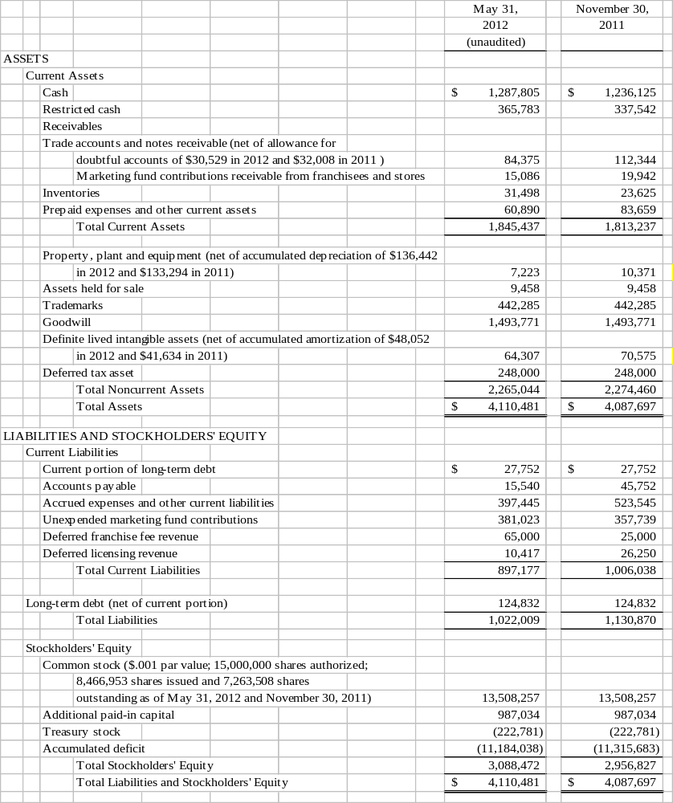
SEE ACCOMPANYING NOTES

BAB, Inc.
Consolidated Statements of Income
For the Six Months Ended May 31, 2012 and 2011
(Unaudited)

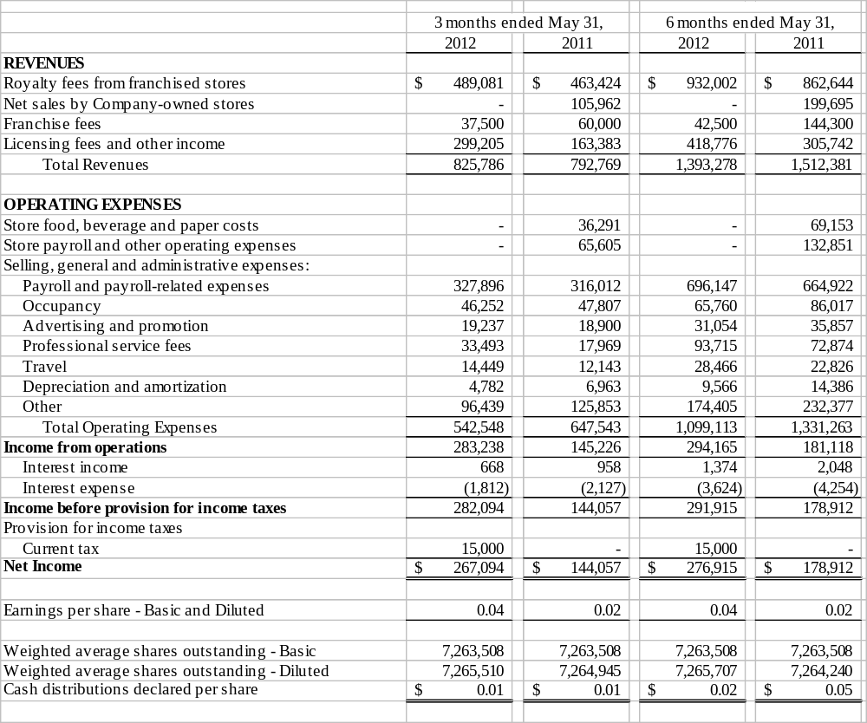
SEE ACCOMPANYING NOTES

BAB, Inc.
Consolidated Statements of Cash Flows
For the Six Months Ended May 31, 2012 and 2011
(Unaudited)

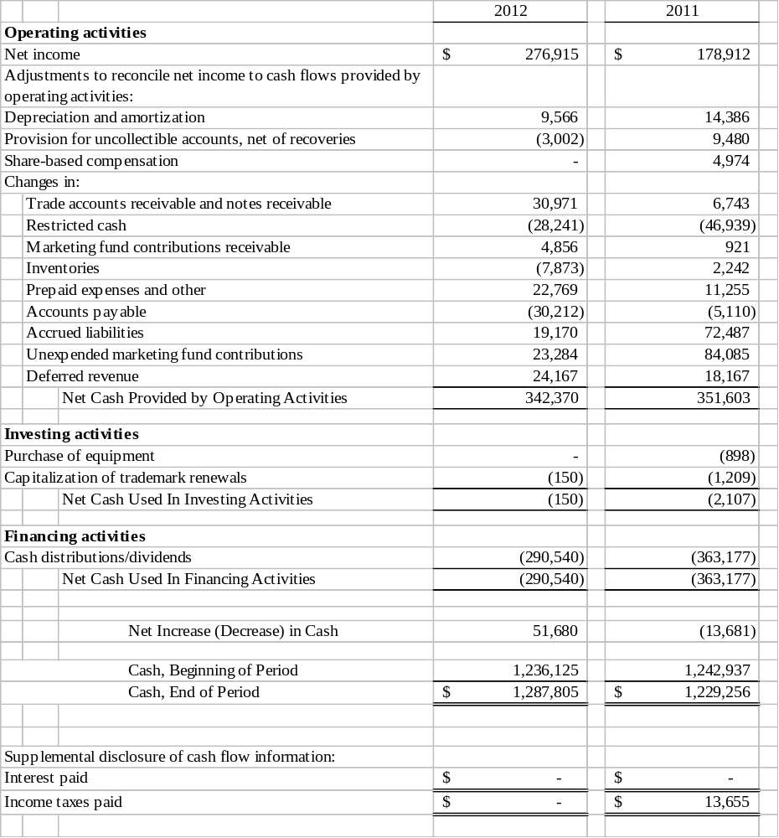

SEE ACCOMPANYING NOTES

BAB, Inc.
Notes to Unaudited Consolidated Financial Statements
Quarter and Year to Date Periods Ended May 31, 2012 and 2011
(Unaudited)

Note 1 - Nature of Operations
BAB, Inc has four wholly owned subsidiaries: BAB Systems, Inc. (“Systems”); BAB Operations, Inc. (“Operations”); Brewster’s Franchise Corporation (“BFC”) and My Favorite Muffin Too, Inc. Systems was incorporated on December 2, 1992, and was primarily established to franchise Big Apple Bagels (“BAB”) specialty bagel retail stores. Operations was formed on August 30, 1995, primarily to operate Company-owned stores, including one which currently serves as the franchise training facility. BFC was established on February 15, 1996 to franchise “Brewster’s Coffee” concept coffee stores. My Favorite Muffin Too, Inc., a New Jersey corporation, was acquired on May 13, 1997. My Favorite Muffin Too, Inc. franchises My Favorite Muffin (“MFM”) concept muffin stores which are included as part of the Systems franchise operating and financial information. The assets of Jacobs Bros. Bagels (“Jacobs Bros.”) were acquired on February 1, 1999. All branded wholesale business uses this trademark.

The Company was incorporated under the laws of the State of Delaware on July 12, 2000. The Company currently franchises and licenses bagel and muffin retail units under the BAB and MFM trade names.
On May 7, 2012 the Company issued a press release announcing the launch of its new franchise concept, SweetDuet Frozen Yogurt & Gourmet Muffins, which it is preparing to roll out this year. While BAB will be offering franchises in all 50 states, its initial development focus is targeted for the Midwest, specifically Illinois, Michigan, Wisconsin and Ohio. As part of its introductory development plan, BAB will be donating 10% of the initial franchise fee from its first 50 units to the Cystic Fibrosis Foundation, of which BAB is a corporate sponsor. SweetDuet, as its name implies, is a fusion concept, pairing self-serve frozen yogurt with BAB’s exclusive line of My Favorite Muffin gourmet muffins, broadening the shop’s offering and therefore differentiating itself from the numerous frozen yogurt outlets already populating the market. SweetDuet Frozen Yogurt & Gourmet Muffins shops will also include BAB’s Brewster’s Coffee and a streamlined breakfast menu. The concept is designed to work in 1600 square feet of space. The SweetDuet concept will be included as part of the Systems franchise operating and financial information.
At May 31, 2012, the Company had 99 franchise units and 6 licensed units in operation in 24 states. The Company additionally derives income from the sale of its trademark bagels, muffins and coffee through nontraditional channels of distribution including to Mrs. Fields Famous Brands (Mrs. Fields), Kohr Bros. Frozen Custard, Braeda Cafe, Kaleidoscoops, Green Beans Coffee, Sodexo and through direct home delivery of specialty muffin gift baskets and coffee.
The accompanying condensed consolidated financial statements are unaudited. These financial statements have been prepared in accordance with the rules and regulations of the Securities and Exchange Commission. Certain information and footnote disclosures normally included in financial statements prepared in accordance with U.S. generally accepted accounting principles have been omitted pursuant to such SEC rules and regulations; nevertheless, the Company believes that the disclosures are adequate to make the information presented not misleading. These financial statements and the notes hereto should be read in conjunction with the financial statements and notes thereto included in the Company's Annual Report on Form 10-K for the year ended November 30, 2011 which was filed February 24, 2012. In the opinion of the Company's management, the condensed consolidated financial statements for the unaudited interim periods presented include all adjustments, including normal recurring adjustments, necessary to fairly present the results of such interim periods and the financial position as of the end of said period. The results of operations for the interim period are not necessarily indicative of the results for the full year.

2. Locations Open and Under Development
Locations which are open or under development at May 31, 2012 are as follows:
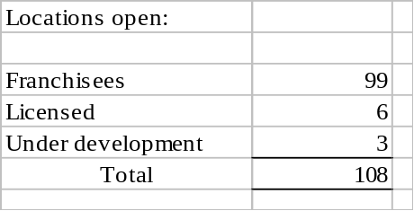

3. Earnings per Share
The following table sets forth the computation of basic and diluted earnings per share:
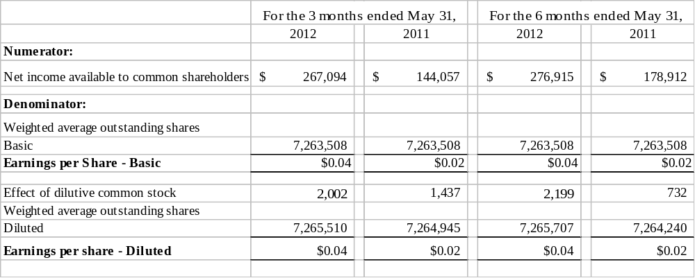
The Company excluded 350,400 and 360,400 potential shares attributable to outstanding stock options from the calculation of diluted earnings per share for the three and six months ended May 31, 2012 and 2011, respectively, because their inclusion would have been anti-dilutive.
4. Long-Term Debt
The total debt balance of $152,584 represents a note payable to a former shareholder that requires an annual payment of $35,000, including interest at 4.75%, due October 1 and running through 2016.

5. Stock Options
In May 2001, the Company approved a Long-Term Incentive and Stock Option Plan (Plan). The Plan reserves 1,400,000 shares of common stock for grant. As of May 31, 2012, 1,400,000 stock options were granted to directors, officers and employees. As of May 31, 2012, there were 1,031,627 stock options exercised or forfeited under the Plan.
 | 6 Months Ended
 | May 31, 2012 |  | May 31, 2011
 | Options |  | Options
Options Outstanding at beginning of period | 368,373 |  | 368,373
Granted | 0 |  | 0
Forfeited | 0 |  | 0
Exercised | 0 |  | 0
Options Outstanding at end of period | 368,373 |  | 368,373
All compensation cost arising from share-based payment arrangements in payroll-related expenses were expensed as of November 30, 2011; there is no share-based compensation cost through May 31, 2012 but there was approximately $5,000 for the six months ending May 31, 2011.
The Company uses historical volatility of common stock over a period equal to the expected life of the options to estimate their fair value. The dividend yield assumption is based on the Company’s history and expectation of future dividend payouts on the common stock. The risk-free interest rate is based on the implied yield available on U.S. treasury zero-coupon issues with an equivalent remaining term. The expected term of the options represents the estimated period of time until exercise and is based on historical experience of similar awards, giving consideration to the contractual terms, vesting schedules and expectations of future employee behavior. To value option grants and other awards for actual and pro forma stock-based compensation, the Company uses the Black-Scholes option valuation model. When the measurement date is certain, the fair value of each option grant is estimated on the date of grant and is based on the assumptions used for the expected stock price volatility, expected term, risk-free interest rates and future dividend payments.

The Company’s stock option terms expire in 10 years and vary in vesting from immediate to a vesting period of five years.

The following table summarizes the stock options outstanding and exercisable at May 31, 2012:

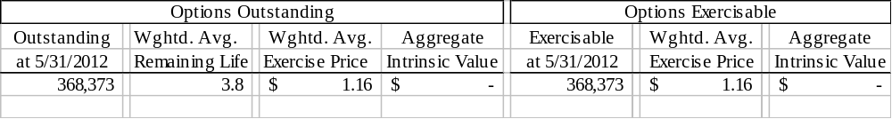
There is no computation for the aggregate intrinsic value in the table above because the outstanding options weighted average exercise price was greater than the Company’s closing stock price of $.62 as of the last business day of the period ended May 31, 2012. No options were exercised during the six month period ended May 31, 2012.

6. Goodwill and Other Intangible Assets
Accounting Standard Codification (“ASC”) 350 (formerly SFAS No. 142) “Goodwill and Other Intangible Assets” requires that assets with indefinite lives no longer be amortized, but instead be subject to annual impairment tests. The Company follows this guidance.

The Company tests goodwill that is not subject to amortization for impairment annually or more frequently if events or circumstances indicate that impairment is possible. Goodwill was tested at the end of the first quarter, February 29, 2012 and it was found that the carrying value of goodwill and intangible assets were not impaired. No events or circumstances occurred in the second quarter of 2012 to indicate that an impairment test was necessary.

The impairment test performed February 29, 2012 was based on a discounted cash flow model using management’s business plan projected for expected cash flows. Based on the computation it was determined that no impairment has occurred. An impairment test was performed at February 28, 2011 and based on the computation using discounted cash flows, it was also determined that no impairment occurred.

7. Segment Information
The following table presents segment information for the six months ended May 31, 2012 and 2011:
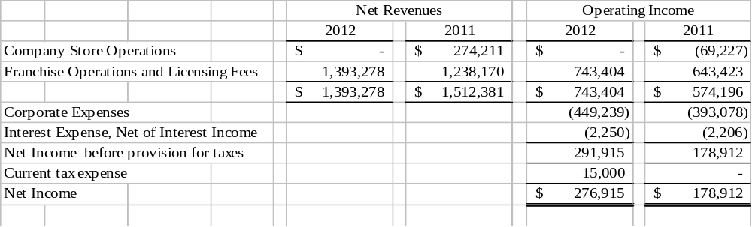
Segment assets changed for the Company-owned store segment at November 30, 2011, as the Company-owned location was converted to a franchise location. The franchise operating and licensing fee segment assets were substantially unchanged for the six months ended May 31, 2012 as compared to November 30, 2011.
8. Recent Accounting Pronouncements
In June 2011, the Financial Accounting Standards Board (“FASB”) issued Accounting Standard Update (“ASU”) No. 2011-05, Comprehensive Income: Presentation of Comprehensive Income. The new guidance requires an entity to present the total of comprehensive income, the components of net income and the components of other comprehensive income either in a single continuous statement of comprehensive income or in two separate but consecutive statements. The guidance eliminates the option to present the components of other comprehensive income as part of the statement of equity. For public entities, the guidance is effective for fiscal years beginning after December 15, 2011. The Company believes that adoption of this guidance will not have any impact on the Company’s consolidated financial position, cash flows or results of operations.

In September 2011, the FASB issued ASU No. 2011-08, Intangibles – Goodwill and Other. The new guidance is intended to simplify goodwill impairment testing by permitting an entity to first perform a qualitative assessment to determine whether it is more likely than not that the fair value of a reporting unit is less than the carrying value before performing the two-step goodwill impairment test that exists currently. The guidance includes a number of events and circumstances for an entity to consider in conducting the qualitative assessment. ASU 2011-08 is effective for goodwill impairment tests performed for fiscal years beginning after December 15, 2011. The Company believes that adoption of this guidance will not have a material impact on the Company’s consolidated financial position, cash flows or results of operations.

Management does not believe that there are any other recently issued and effective, or not yet effective, pronouncements as of May 31, 2012 that would have, or are expected to have, any significant effect on the Company’s consolidated financial position, cash flows or results of operations.

9. Equity

Included in accrued expenses and other liabilities at May 31, 2012 is a cash distribution/dividend payable in the amount of $72,635 declared May 25, 2012 and payable July 6, 2012. Included in accrued expenses and other liabilities at November 30, 2011 is a cash distribution/dividend payable in the amount of $217,905 declared November 28, 2011 and payable January 4, 2012.

ITEM 2. | MANAGEMENT'S DISCUSSION AND ANALYSIS OF FINANCIAL CONDITION AND RESULTS OF OPERATIONS
Certain statements contained in Management's Discussion and Analysis of Financial Condition and Results of Operations, including statements regarding the development of the Company's business, the markets for the Company's products, anticipated capital expenditures, and the effects of completed and proposed acquisitions, and other statements contained herein regarding matters that are not historical facts, are forward-looking statements as is within the meaning of Section 27A of the Securities Act of 1933 and Section 21E of the Securities Exchange Act of 1934. Because such statements include risks and uncertainties, actual results could differ materially from those expressed or implied by such forward-looking statements as set forth in this report, the Company's Annual Report on Form 10-K and other reports that the Company files with the Securities and Exchange Commission. Certain risks and uncertainties are wholly or partially outside the control of the Company and its management, including its ability to attract new franchisees; the continued success of current franchisees; the effects of competition on franchisees and Company-owned store results; consumer acceptance of the Company's products in new and existing markets; fluctuation in development and operating costs; brand awareness; availability and terms of capital; adverse publicity; acceptance of new product offerings; availability of locations and terms of sites for store development; food, labor and employee benefit costs; changes in government regulation (including increases in the minimum wage); regional economic and weather conditions; the hiring, training, and retention of skilled corporate and restaurant management; and the integration and assimilation of acquired concepts. Accordingly, readers are cautioned not to place undue reliance on these forward-looking statements, which reflect management's analysis only as of the date hereof. The Company undertakes no obligation to publicly release the results of any revision to these forward-looking statements which may be made to reflect events or circumstances after the date hereof or to reflect the occurrence of unanticipated events.

General
There are 99 franchised and 6 licensed units at May 31, 2012. Units in operation at May 31, 2011 included 1 Company-owned store, 98 franchised and 7 licensed units. System-wide revenues for the six months ended May 31, 2012 were $19.1 million as compared to May 31, 2011 which were $17.9 million.
The Company's revenues are derived primarily from the ongoing royalties paid to the Company by its franchisees and receipt of initial franchise fees. Additionally, the Company derives revenue from the sale of licensed products (My Favorite Muffin mix, Big Apple Bagels cream cheese and Brewster's coffee), and through licensing and nontraditional channels of distribution (Kohr Bros., Braeda Café, Kaleidoscoops, Green Beans Coffee, Sodexo and Mrs. Fields). Also included in licensing fees and other income is Operation’s Sign Shop revenue. The Sign Shop provides the majority of signage, which includes but is not limited to, posters, menu panels, build charts, outside window stickers and counter signs to franchisees to provide consistency and convenience.
Royalty fees from franchised stores represent a 5% fee on net retail and wholesale sales of franchised units. Royalty revenues are recognized on an accrual basis using actual franchise receipts. Generally, franchisees report and remit royalties on a weekly basis. The majority of month-end receipts are recorded on an accrual basis based on actual numbers from reports received from franchisees shortly after the month-end. Estimates are utilized in certain instances where actual numbers have not been received and such estimates are based on the average of the last 10 weeks’ actual reported sales.
The Company recognizes franchise fee revenue upon the opening of a franchise store. Direct costs associated with the franchise sale are deferred until the franchise fee revenue is recognized. These costs include site approval, construction approval, commissions, blueprints and training costs.

The Company earns a licensing fee from the sale of BAB branded products, which includes coffee, cream cheese, muffin mix, scoop and bake muffin batter and par baked bagels from a third-party commercial bakery to the franchised and licensed units.

As of May 31, 2012, the Company employed 13 full-time and 4 part-time employees at the Corporate office. The employees are responsible for corporate management and oversight, accounting, advertising and franchising. None of the Company's employees are subject to any collective bargaining agreements and management considers its relations with its employees to be good.

Results of Operations
Three Months Ended May 31, 2012 versus Three Months Ended May 31, 2011
For the three months ended May 31, 2012 and 2011, the Company reported net income of $267,000 and $144,000, respectively. Total revenue of $826,000 increased $33,000, or 4.2%, for the three months ended May 31, 2012, as compared to total revenue of $793,000 for the three months ended May 31, 2011.
Royalty fee revenue of $489,000, for the quarter ended May 31, 2012, increased $26,000, or 5.6%, from the $463,000 for quarter ended May 31, 2011. The Company had 99 franchise locations at May 31, 2012 and 98 at May 31, 2011. The increase in royalty revenue is primarily due to one additional location, an April and May national bagel and muffin sale and the slowly improving economy for the fast food industry.
Franchise fee revenue of $38,000, for the quarter ended May 31, 2012, decreased $22,000, or 36.7%, compared to $60,000 in the same three month period last year. There was one store opened and three transfers in the second quarter 2012 versus two store openings and two transfers in the same period in 2011.

Licensing fee and other income of $299,000, for the quarter ended May 31, 2012, increased $136,000, or 83.4%, from $163,000 for the quarter ended May 31, 2011. Franchise settlement revenue of $172,000 in the second quarter of 2012 included a settlement of $171,000 versus $12,000 in 2011. There was a $7,000 franchise audit adjustment in 2012 and none in the same period 2011. This was offset by a decrease in Sign Shop revenue of $16,000 and licensing revenue of $15,000 in 2012 compared to same period in 2011.
The one Company-owned store became a franchisee on November 30, 2011. There were no Company-owned store sales for the second quarter 2012 versus $106,000 for same period in 2011.
Total operating expenses of $543,000 decreased $105,000, or 16.2%, for the quarter ended May 31, 2012, from $648,000 in 2011. The decrease in total operating expenses in 2012 as compared to same period 2011 was primarily due to no Company-owned store expenses in the second quarter of 2012 versus $102,000 for the same period in 2011. There was a $23,000 decrease in Sign Shop cost of sales and a $7,000 decrease in bad debt expense which was the result of bad debt recovery in 2012 versus an increase in the reserve for a note receivable in 2011. This was offset by a $12,000 increase in payroll expense and a $15,000 increase in legal expenses, which were primarily incurred for the SweetDuet concept, in the second quarter 2012 versus same period 2011.
Interest income was $1,000 for May 31, 2012 and 2011.
Interest expense was $2,000 for May 31, 2012 and 2011.
State income tax expense of $15,000 was recorded in 2012 versus none in 2011.
Earnings per share, as reported for basic and diluted outstanding shares for second quarter ended May 31, 2012 and 2011 was $0.04 and $0.02, respectively.

Six Months Ended May 31, 2012, versus Nine Months Ended May 31, 2011
For the six months ended May 31, 2012, the Company reported net income of $277,000 versus $179,000 for the same period in 2011. Total revenue of $1,393,000 decreased $119,000, or 7.9%, for the six months ended May 31, 2012, as compared to total revenue of $1,512,000 for the six months ended May 31, 2011. This decrease in total revenues was due to the company-owned store being transferred to a franchisee at November 30, 2011. Company-owned stores sales in 2011 were $200,000. Royalty, franchise and licensing fee and other revenue increased $81,000 for the six months ended May 31, 2012 versus same period 2011.
Royalty fee revenue of $932,000, for the six months ended May 31, 2012, increased $69,000, or 8.0%, from $863,000 for the six months ended May 31, 2011. The Company had 99 franchise locations at May 31, 2012 compared to 98 Franchise locations in 2011. Franchise sales increased due to a bagel sale in April and a muffin sale in May, one additional franchise unit, a mild midwest winter and the improving economy for the fast food industry.
Franchise fee revenue of 43,000, for the six months ended May 31, 2012, decreased $101,000, or 70.1% from $144,000 for the six months ended May 31, 2011. One store opened and 4 transferred in 2012 compared to five stores opening and five transfers during the same period in 2011.
Licensing fee and other income of $419,000, for the six months ended May 31, 2012, increased $113,000, or 36.9%, from $306,000 for the six months ended May 31, 2011. In 2012 there was settlement income of $173,000, including a $171,000 settlement versus $26,000 of settlement income in 2011. This $147,000 increase was offset by a $32,000 decrease in Sign Shop revenue.

Total operating expenses of $1,099,000 decreased $232,000 or 17.4%, for the six months ended May 31, 2012, from $1,331,000 in 2011. There were no Company-owned store expenses in 2012 versus $202,000 in 2011. The remaining decrease in expenses for 2012 was due to a decrease of $20,000 in occupancy expenses due to a construction allowance in 2012, a decrease in bad debt expense of $12,000 which consisted of bad debt recovery of $3,000 in 2012 versus bad debt expense of $9,000 in 2011. In addition there were no Company-owned other SG&A expenses in 2012 versus $16,000 in 2011, a decrease in franchise expenses of $13,000 because fewer new stores opened in 2012, a decrease of $23,000 in Sign Shop expenses and a decrease in depreciation and amortization of $5,000 in 2012 versus 2011. This was offset by an increase in payroll expense of $31,000, which included a full time franchise trainer in 2012, an increase in legal expenses of $21,000 of which $15,000 was for the SweetDuet concept, an increase in travel of $6,000 and an increase in filing expenses for newly instituted XBRL of $6,000 in 2012 versus 2011.
Interest income of $1,000 decreased $1,000, or 50.0%, for the six months ended May 31, 2012, from $2,000 for the same period in 2011. This was due to lower interest rates.
Interest expense for each of the six months ended May 31, 2012 and 2011, was $4,000.
State income tax expense of $15,000 was recorded in 2012 versus none in 2011.
Earnings per share, as reported for basic and diluted outstanding shares for the six months ended May 31, 2012, and 2011 was $0.04 and $0.02, respectively.

Liquidity and Capital Resources
At May 31, 2012, the Company had working capital of $948,000 and unrestricted cash of $1,288,000. At November 30, 2011 the Company had working capital of $807,000 and unrestricted cash of $1,236,000.

During fiscal 2012, the Company had net income of $277,000 and operating activities provided cash of 342,000. The principal adjustments to reconcile net income to cash generated in operating activities were depreciation and amortization of $10,000, less provision for uncollectible accounts of $3,000. In addition, changes in operating assets and liabilities increased cash by $58,000. During fiscal 2011, the Company had net income of $179,000 and operating activities provided cash of $352,000. The principal adjustments to reconcile net income to cash provided by operating activities in 2011 were depreciation and amortization of $14,000, share-based compensation of $5,000 and the provision for uncollectible accounts of $9,000. In addition changes in operating assets and liabilities increased cash by $145,000.

As of May 31, 2012, the Company used $150 for investing activities whereas during fiscal 2011, the Company used $2,000 for equipment and trademark renewals.

The Company used $291,000 and $363,000 for cash distribution/dividend payments during the six month periods ended May 31, 2012 and 2011, respectively.

Although there can be no assurances that the Company will be able to pay cash distributions/dividends in the future, it is the Company’s intent that future cash distributions/dividends will be considered based on profitability expectations and financing needs and will be declared at the discretion of the Board of Directors. It is the Company’s intent going forward to declare and pay cash distributions/dividends on a quarterly basis if warranted. On May 25, 2012, the Board of Directors authorized a $0.01 per share quarterly cash distribution/dividend. The cash distribution was paid July 6, 2012 to shareholders of record as of June 18, 2012.

The Company believes execution of its cash distribution/dividend policy will not have any material adverse effects on its cash or its ability to fund current operations or future capital investments.

The Company has no financial covenants on its outstanding debt.

Cash Distribution and Dividend Policy
It is the Company’s intent that future cash distributions/dividends will be considered after reviewing profitability expectations and financing needs and will be declared at the discretion of the Board of Directors. Due to the general economic downturn and its impact on the Company, there can be no assurance that the Company will generate sufficient earnings to pay out cash distributions/dividends. The Company will continue to analyze its ability to pay cash distributions/dividends on a quarterly basis.
The Company believes that for tax purposes the cash distribution declared in 2012 may be treated as a return of capital to stockholders depending on each stockholder’s basis or it may be treated as a dividend or a combination of the two. Determination of whether it is a cash distribution, cash dividend or combination of the two will not be made until after December 31, 2012, as the classification or combination is dependent upon the Company’s earnings and profits for tax purposes for its fiscal year ending November 30, 2012.
The Company believes execution of this policy will not have any material adverse effect on its ability to fund current operations or future capital investments.
Recent Accounting Pronouncements
In June 2011, the Financial Accounting Standards Board (“FASB”) issued Accounting Standard Update (“ASU”) No. 2011-05, Comprehensive Income: Presentation of Comprehensive Income. The new guidance requires an entity to present the total of comprehensive income, the components of net income and the components of other comprehensive income either in a single continuous statement of comprehensive income or in two separate but consecutive statements. The guidance eliminates the option to present the components of other comprehensive income as part of the statement of equity. For public entities, the guidance is effective for fiscal years beginning after December 15, 2011. The Company believes that adoption of this guidance will not have any impact on the Company’s consolidated financial position, cash flows or results of operations.

In September 2011, the FASB issued ASU No. 2011-08, Intangibles – Goodwill and Other. The new guidance is intended to simplify goodwill impairment testing by permitting an entity to first perform a qualitative assessment to determine whether it is more likely than not that the fair value of a reporting unit is less than the carrying value before performing the two-step goodwill impairment test that exists currently. The guidance includes a number of events and circumstances for an entity to consider in conducting the qualitative assessment. ASU 2011-08 is effective for goodwill impairment tests performed for fiscal years beginning after December 15, 2011. The Company believes that adoption of this guidance will not have a material impact on the Company’s consolidated financial position, cash flows or results of operations.

Management does not believe that there are any other recently issued and effective, or not yet effective, pronouncements as of February 29, 2012 that would have, or are expected to have, any significant effect on the Company’s consolidated financial position, cash flows or results of operations.

Critical Accounting Policies
The Company has identified significant accounting policies that, as a result of the judgments, uncertainties, uniqueness and complexities of the underlying accounting standards and operations involved could result in material changes to its financial condition or results of operations under different conditions or using different assumptions. The Company's most critical accounting policies are related to revenue recognition, valuation of long-lived and intangible assets, deferred tax assets and the related valuation allowance. Details regarding the Company's use of these policies and the related estimates are described in the Company's Annual Report on Form 10-K for the fiscal year ended November 30, 2011, filed with the Securities and Exchange Commission on February 24, 2012. There have been no material changes to the Company's critical accounting policies that impact the Company's financial condition, results of operations or cash flows for the six months ended May 31, 2012.

ITEM 3. | QUANTITATIVE AND QUALITATIVE DISCLOSURE ABOUT MARKET RISK
BAB, Inc. has no interest, currency or derivative market risk.

ITEM 4. | CONTROLS AND PROCEDURES

Evaluation of Disclosure Controls and Procedures

Our management, with the participation of both our Chief Executive Officer and Chief Financial Officer, has evaluated the effectiveness of our disclosure controls and procedures (as defined in Rules 13a-15(e) under the Securities and Exchange Act of 1934, as amended (the “Exchange Act”), as of the end of the period covered by this report. Based on such evaluation, both our Chief Executive Officer and Chief Financial Officer have concluded that, as of May 31, 2012 our disclosure controls and procedures are effective (i) to ensure that information required to be disclosed by us in the reports that we file or submit under the Exchange Act is recorded, processed, summarized and reported within the time periods specified in the SEC’s rules and forms and (ii) to ensure that information required to be disclosed by us in the reports that we submit under the Exchange Act is accumulated and communicated to our management, including our executive and financial officers, or persons performing similar functions, as appropriate, to allow timely decisions regarding required disclosure.
Changes in Internal Control Over Financial Reporting
There have been no changes in our internal control over financial reporting (as such term is defined in Rules 13a-15(f) and 15(d)-15(f) under the Exchange Act) during the six months of fiscal year 2012 to which this report relates that have materially affected, or are reasonably likely to materially affect, our internal control over financial reporting.

Compliance with Section 404 of Sarbanes-Oxley Act

The Company is in compliance with Section 404 of the Sarbanes-Oxley Act of 2002 (the “Act”).

PART II
ITEM 1. | LEGAL PROCEEDINGS
None.
ITEM 2. | UNREGISTERED SALES OF EQUITY AND USE OF PROCEEDS
None.
ITEM 3. | DEFAULTS UPON SENIOR SECURITIES
None.
ITEM 4. | OTHER INFORMATION
None.
ITEM 5. | EXHIBITS
See index to exhibits

SIGNATURE
In accordance with the requirements of the Exchange Act, the registrant has duly caused this report to be signed on its behalf by the undersigned, thereunto duly authorized.
BAB, Inc.
Dated: July 13, 2012 | /s/ Jeffrey M. Gorden
 | Jeffrey M. Gorden
 | Chief Financial Officer

INDEX TO EXHIBITS
(a) EXHIBITS
The following exhibits are filed herewith.
 | INDEX NUMBER | DESCRIPTION
 | 21.1 | List of Subsidiaries of the Company
 | 31.1 | Section 302 of the Sarbanes-Oxley Act of 2002 Certification of Chief Executive Officer
 | 31.2 | Section 302 of the Sarbanes-Oxley Act of 2002 Certification of Chief Financial Officer
 | 32.1 | Section 906 of the Sarbanes-Oxley Act of 2002 Certification of Chief Executive Officer
 | 32.2 | Section 906 of the Sarbanes-Oxley Act of 2002 Certification of Chief Financial Officer
 | Exhibit 21.1
SUBSIDIARIES OF BAB, INC.

BAB Systems, Inc., an Illinois corporation
BAB Operations, Inc., an Illinois corporation
Brewster's Franchise Corporation, an Illinois corporation
My Favorite Muffin Too, Inc., a New Jersey corporation
BAB Investments, Inc., an Illinois corporation

Exhibit 31.1
CERTIFICATION OF THE CHIEF EXECUTIVE OFFICER PURSUANT TO RULE 13A-14 (a) OR RULE 15d-14 (a) OF THE SECURITIES EXCHANGE ACT OF 1934.
I, Michael W. Evans, certify that:
- I have reviewed this quarterly report on Form 10-Q of BAB, Inc.
- Based on my knowledge, this report does not contain any untrue statement of a material fact or omit to state a material fact necessary to make the statements made, in light of the circumstances under which such statements were made, not misleading with respect to the period covered by this report;
- Based on my knowledge, the financial statements, and other financial information included in this report, fairly present in all material respects the financial condition, results of operations and cash flows of the registrant as of, and for, the periods presented in this report;
- The registrant’s other certifying officer(s) and I are responsible for establishing and maintaining disclosure controls and procedures (as defined in Exchange Act Rules 13a -15(e) and 15d -15(e)) and internal control over financial reporting (as defined in Exchange Act Rules 13a – 15(f) and 15d -15(f)) for the registrant and have:
  - Designed such disclosure controls and procedures, or caused such disclosure controls and procedures to be designed under our supervision, to ensure that material information relating to the registrant, including its consolidated subsidiaries, is made known to us by others within those entities, particularly during the period in which this report is being prepared;
  - Designed such internal control over financial reporting, or caused such internal control over financial reporting to be designed under our supervision, to provide reasonable assurance regarding the reliability of financial reporting and the preparation of financial statements for external purposes in accordance with generally accepted accounting principles;
  - Evaluated the effectiveness of the registrant’s disclosure controls and procedures and presented in this report our conclusions about the effectiveness of the disclosure controls and procedures, as of the end of the period covered by this report based on such evaluation; and
  - Disclosed in this report any change in the registrant’s internal control over financial reporting that occurred during the registrant’s most recent fiscal quarter (the registrant’s fourth fiscal quarter in the case of an annual report) that has materially affected, or is reasonably likely to materially affect, the registrant’s internal control over financial reporting; and
- The registrant’s other certifying officer(s) and I have disclosed, based on our most recent evaluation of internal control over financial reporting, to the registrant’s auditors and the audit committee of the registrant’s board of directors (or persons performing the equivalent functions):
  - All significant deficiencies and material weaknesses in the design or operation of internal control over financial reporting which are reasonably likely to adversely affect the registrant’s ability to record, process, summarize and report financial information; and
  - Any fraud, whether or not material, that involves management or other employees who have a significant role in the registrant’s internal control over financial reporting.

Date July 13, 2012 by / s/ Michael W. Evans
Michael W. Evans, Chief Executive Officer

Exhibit 31.2
CERTIFICATION OF CHIEF FINANCIAL OFFICER PURSUANT TO RULE 13A-14 (a) OR RULE 15d-14 (a) OF THE SECURITIES EXCHANGE ACT OF 1934.
I, Jeffrey M. Gorden, certify that:
- I have reviewed this quarterly report on Form 10-Q of BAB, Inc.
- Based on my knowledge, this report does not contain any untrue statement of a material fact or omit to state a material fact necessary to make the statements made, in light of the circumstances under which such statements were made, not misleading with respect to the period covered by this report;
- Based on my knowledge, the financial statements, and other financial information included in this report, fairly present in all material respects the financial condition, results of operations and cash flows of the small business issuer as of, and for, the periods presented in this report;
- The registrant’s other certifying officer(s) and I are responsible for establishing and maintaining disclosure controls and procedures (as defined in Exchange Act Rules 13a -15(e) and 15d -15(e)) and internal control over financial reporting (as defined in Exchange Act Rules 13a–15(f) and 15d -15(f)) for the registrant and have:
  - Designed such disclosure controls and procedures, or caused such disclosure controls and procedures to be designed under our supervision, to ensure that material information relating to the registrant, including its consolidated subsidiaries, is made known to us by others within those entities, particularly during the period in which this report is being prepared;
  - Designed such internal control over financial reporting, or caused such internal control over financial reporting to be designed under our supervision, to provide reasonable assurance regarding the reliability of financial reporting and the preparation of financial statements for external purposes in accordance with generally accepted accounting principles;
  - Evaluated the effectiveness of the registrant’s disclosure controls and procedures and presented in this report our conclusions about the effectiveness of the disclosure controls and procedures, as of the end of the period covered by this report based on such evaluation; and
  - Disclosed in this report any change in the registrant’s internal control over financial reporting that occurred during the registrant’s most recent fiscal quarter (the registrant’s fourth fiscal quarter in the case of an annual report) that has materially affected, or is reasonably likely to materially affect, the registrant’s internal control over financial reporting; and
- The registrant’s other certifying officer and I have disclosed, based on our most recent evaluation of internal control over financial reporting, to the registrant’s auditors and the audit committee of the registrant’s board of directors (or persons performing the equivalent functions):
  - All significant deficiencies and material weaknesses in the design or operation of internal control over financial reporting which are reasonably likely to adversely affect the registrant’s ability to record, process, summarize and report financial information; and
  - Any fraud, whether or not material, that involves management or other employees who have a significant role in the registrant’s internal control over financial reporting.

Date: July 13, 2012 By: /s/ Jeffrey M. Gorden
Jeffrey M. Gorden, Chief Financial Officer

Exhibit 32.1
BAB, Inc.
CERTIFICATION PURSUANT TO 18 U.S.C. SECTION 1350
AS ADOPTED PURSUANT TO SECTION 906 OF THE SARBANES-OXLEY ACT OF 2002
In connection with the BAB, Inc. (the "Company") Quarterly Report on Form 10-Q for the period ended May 31, 2012, as filed with the Securities and Exchange Commission on the date hereof (the "Report"), I, Michael W. Evans, Chief Executive Officer of the Company, certify pursuant to 18 U.S.C. Section 1350, as adopted pursuant to Section 906 of the Sarbanes-Oxley Act of 2002, that, to the best of my knowledge:
- The Report fully complies with the requirements of section 13(a) or 15(d) of the Securities and Exchange Act of 1934, as amended; and
- The information contained in the Report fairly presents, in all material respects, the financial condition, results of operations, and cash flows of the Company.
Date: July 13, 2012 By: /s/ Michael W. Evans
Michael W. Evans, Chief Executive Officer

Exhibit 32.2

BAB, Inc.
CERTIFICATION PURSUANT TO 18 U.S.C. SECTION 1350
AS ADOPTED PURSUANT TO SECTION 906 OF THE SARBANES-OXLEY ACT OF 2002
In connection with the BAB, Inc. (the "Company") Quarterly Report on Form 10-Q for the period ended May 31, 2012, as filed with the Securities and Exchange Commission on the date hereof (the "Report"), I, Jeffrey M. Gorden, Chief Financial Officer of the Company, certify pursuant to 18 U.S.C. Section 1350, as adopted pursuant to Section 906 of the Sarbanes-Oxley Act of 2002, that, to the best of my knowledge:
- The Report fully complies with the requirements of section 13(a) or 15(d) of the Securities and Exchange Act of 1934, as amended; and
- The information contained in the Report fairly presents, in all material respects, the financial condition, results of operations, and cash flows of the Company.

Date: July 13, 2012 By: /s/ Jeffrey M. Gorden
Jeffrey M. Gorden, Chief Financial Officer

